SCHCHAGAS Setup
- Copy/sftp the SCHCHAGAS.tar.gz file in to /home/sbcsys directory by sbcsys user
- Login to the server using Putty by sbcsys user.
- Un TAR the SCHCHAGAS.tar.gz file using below screenshot command
tar -xvzf SCHCHAGAS.tar.gz)

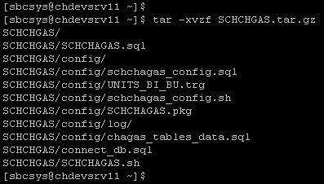

- All required configuration files, shell scripts & required sub directories will extract into SCHCHAGAS directory under /home/sbcsys directory
- Run the below screenshot command to create and configure the SCHCHAGAS environment in the lab database.
- Shell script will prompt you for database name. Enter plab or qlab or tlab
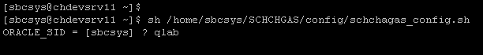
- It will setup the required SCHCHAGAS database objects under OPS$SBCSYS schema
- Verify all the log files under /home/sbcsys/SCHCHAGAS/config/log directory for any errors
- Setup the SCHCHAGAS.sh shell script in CRON Job like below screenshot
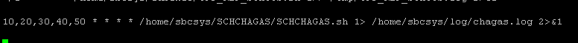
- Need to modify the shell script according to database names etc..
- Please Contact Mediware Tech Support If any issues.

